**EXP NO: 05 DATE:**

# RECOGNIZE A VALID VARIABLE WHICH STARTS WITH A LETTER FOLLOWED BY ANY NUMBER OF LETTERS OR DIGITS USING LEX AND YACC

Problem Statement:

Recognizes a valid variable name. The variable name must start with a letter (either uppercase or lowercase) and can be followed by any number of letters or digits. The program should validate whether a given string adheres to this naming convention.

# AIM:

To develop a **LEX and YACC program** that recognizes a **valid variable name** in C programming, which:

* Starts with a **letter** (a-z or A-Z)
* Followed by **any number of letters or digits** (a-z, A-Z, 0-9, _)
* **Does not allow** invalid characters (e.g., 123abc, @var, x!y)

# ALGORITHM:

**Step 1:** A Yacc source program has three parts as follows: Declarations %% translation rules

%% supporting C routines

**Step 2:** Declarations Section: This section contains entries that:

Include standard I/O header file. Define global variables.

Define the list rule as the place to start processing. Define the tokens used by the parser.

**Step 3:** Rules Section: The rules section defines the rules that parse the input stream. Each rule of a grammar production and the associated semantic action.

**Step 4:** Programs Section: The programs section contains the following subroutines. Because these subroutines are included in this file, it is not necessary to use the yacc library when processing this file.

Main- The required main program that calls the yyparse subroutine to start the program. yyerror(s) -This error-handling subroutine only prints a syntax error message.

yywrap -The wrap-up subroutine that returns a value of 1 when the end of input occurs. The calc.lex file contains include statements for standard input and output, as programmer file

information if we use the -d flag with the yacc command. The y.tab.h file contains definitions for

the tokens that the parser program uses.

**Step 5:**calc.lex contains the rules to generate these tokens from the input stream.

# PROGRAM:

Lex.l

%{

#include "yac.tab.h" #include <stdio.h>

int yywrap(void) { return 1;

}

%}

%%

[a-zA-Z_][a-zA-Z0-9_]* { return IDENTIFIER; }

\n { return 0; }

. { return yytext[0]; }

%%

Yac.y

%{

#include <stdio.h> #include <stdlib.h>

extern char *yytext; int yylex();

int yyerror(char *msg);

%}

%token IDENTIFIER

%%

variable: IDENTIFIER { printf("Valid variable name: %s\n", yytext); }

;

%%

int main() {

printf("Enter a variable name:\n"); yyparse();

return 0;

}

int yyerror(char *msg) { printf("Error: %s\n", msg); return 0;

}

# OUTPUT :

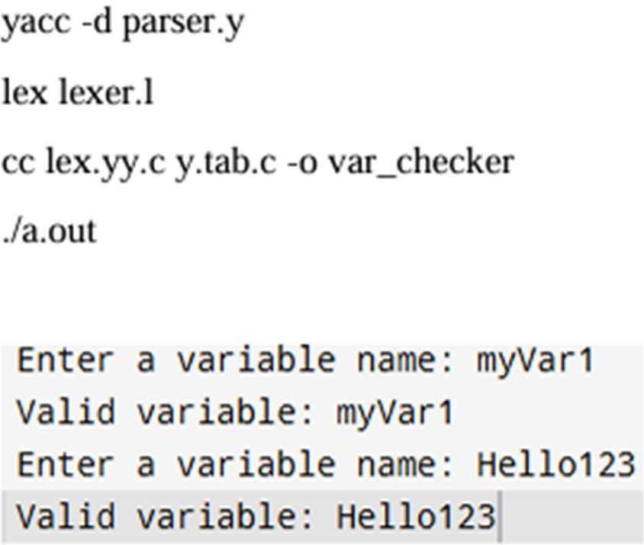

|  |  |
| --- | --- |
| **Implementation** |  |
| **Output/Signature** |  |

**RESULT:**

Thus the above program reads an input string, checks whether it follows the rules for a valid variable name, and produces the following output.